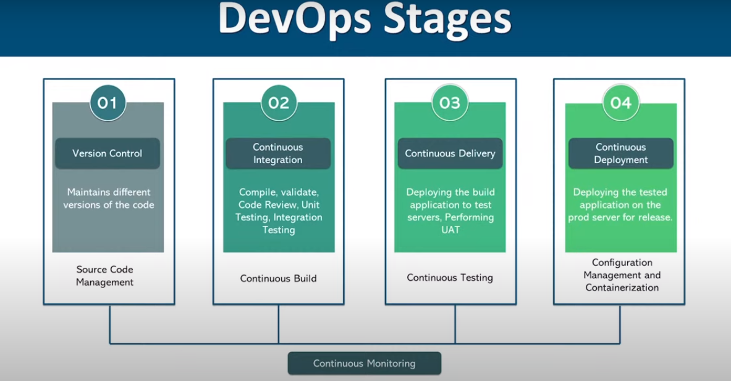



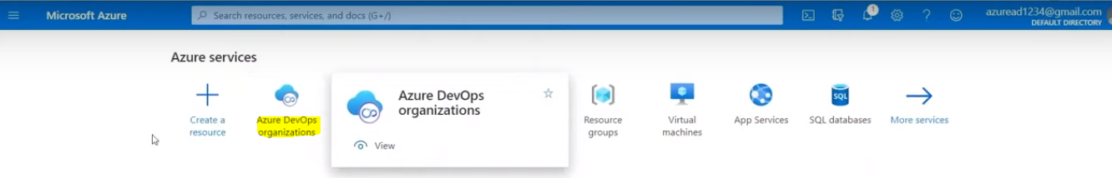



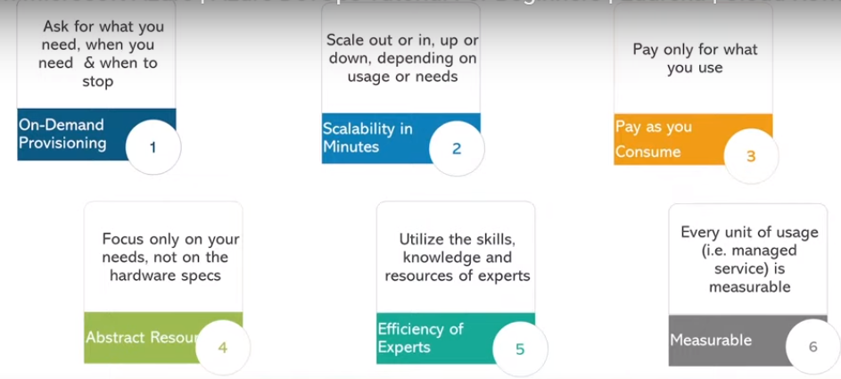

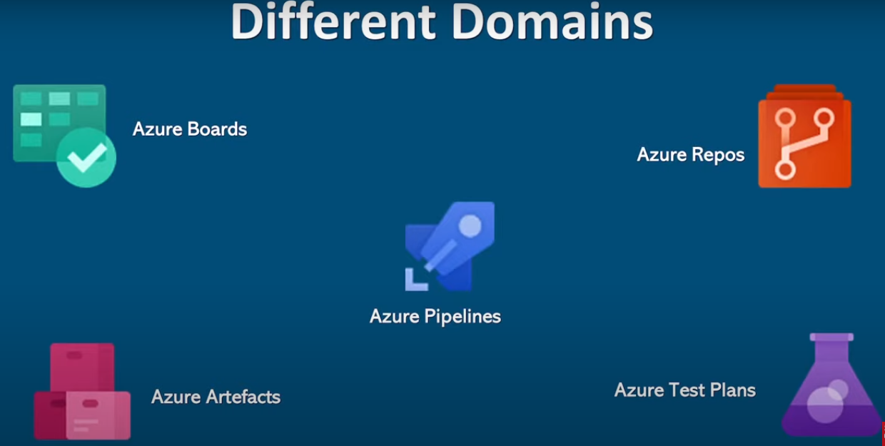

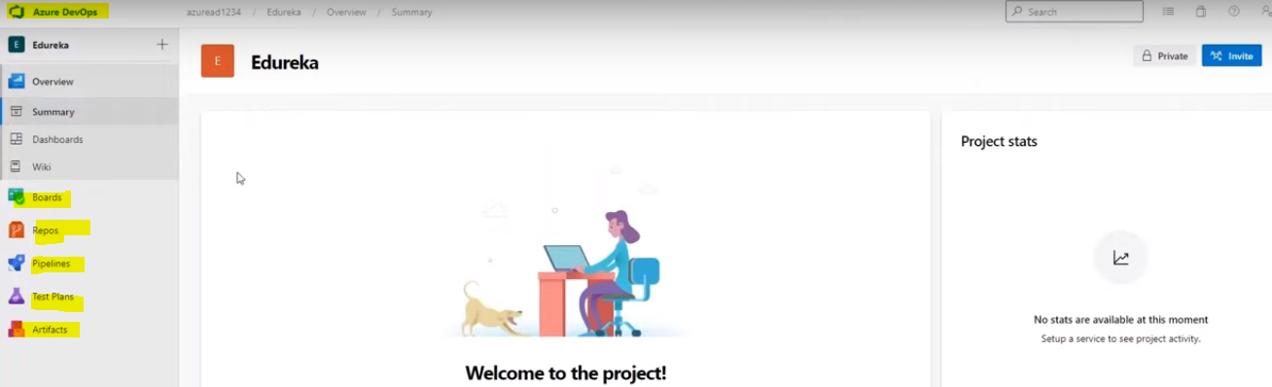







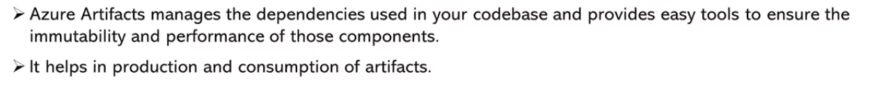

<https://www.youtube.com/watch?v=TS-7x9Zn-Yk>

<https://www.youtube.com/watch?v=MoFAR_6KDFo>

<https://www.youtube.com/watch?v=vBx7WY25fM0>